* + Important topics (lec 29, 30, 43, 44)
  + Idea behind docker? (namespace and cgroup concepts)
  + How docker build works? (lecture 029and 030)
  + Docker kill vs docker stop command?
  + How to create an image out of a container? (lec 33)
  + How to avoid rebuilding of image cache when the project file has changed? (lec 43, 44)
  + How to automatically restart a container?
  + How to ensure that changes in the project file should reflect in the container? (66, 67)
  + Docker attach?
  + Executing Tests using our docker Container. (71 - 74)

At lec 74!

Now start with kubernetes

* + About Docker

* + What is docker?
    - **Platform for creating containerized apps.**

* + What docker solves?
  + To make i**nstalling and running a software easily** on any given computer (or server or cloud based platform) without worrying about setup or dependencies.

* + Containers:
    - **A solution to run the software reliably when moved from one computing environment to another. That is, from developers laptop to test environment, from a staging environment to production,**
    - **A container provides an isolated environment where an app, together with its environment can run.**

**and perhaps from a physical machine in a data center to a virtual machine in a private or public cloud.**

* + For example -

You're going to test using Python 2.7, and then it's going to run on Python 3 in production and something weird will happen. Or you'll rely on the behavior of a certain version of an SSL library and another one will be installed. You'll run your tests on Debian and production is on Red Hat and all sorts of weird things happen."

* + Containers are nothing like a Virtual Machine. **They are just like a process in our host operation system.**

- **a container consists of an entire runtime environment: an application, plus all its dependencies, libraries and other binaries, and configuration files needed to run it, bundled into one package.**

* + What is docker?
  + 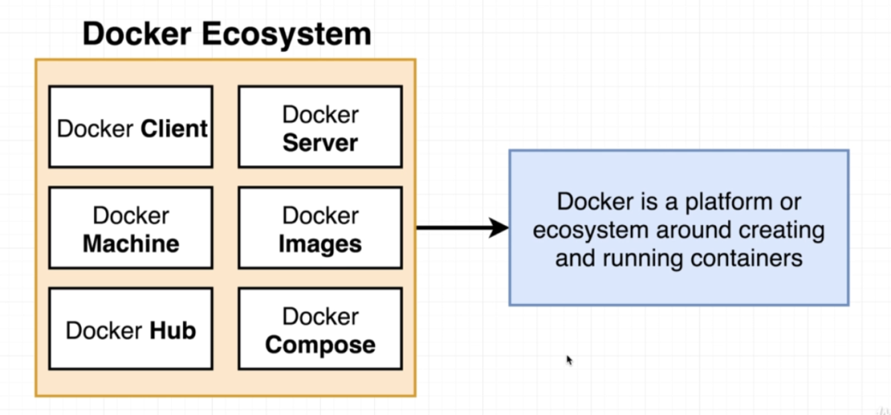
  + Images and containers in docker

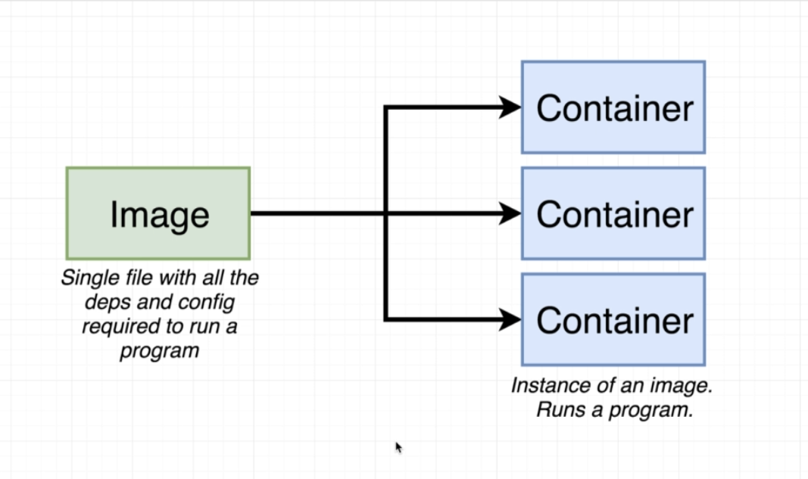

* + When we run a docker command, the docker cli connects with docker server. Docker server then sees if there is a local image in the image cache. If not, then it connects with the docker hub and downloads a file called an Image for that software.
  + Container is an instance of an image and can be considered as a running program.
  + Container is a program having:

a) own isolated set of hardware resources.

b) own little space of networking technology.

c) own little space memory

- Following things happen when we run a docker command :

* + 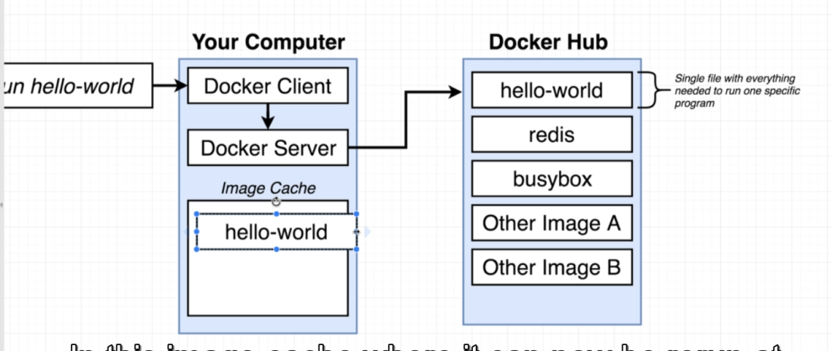

----------------------------------------------------------------------------------------------

* + What is a container actually?

a) how our OS works?

-

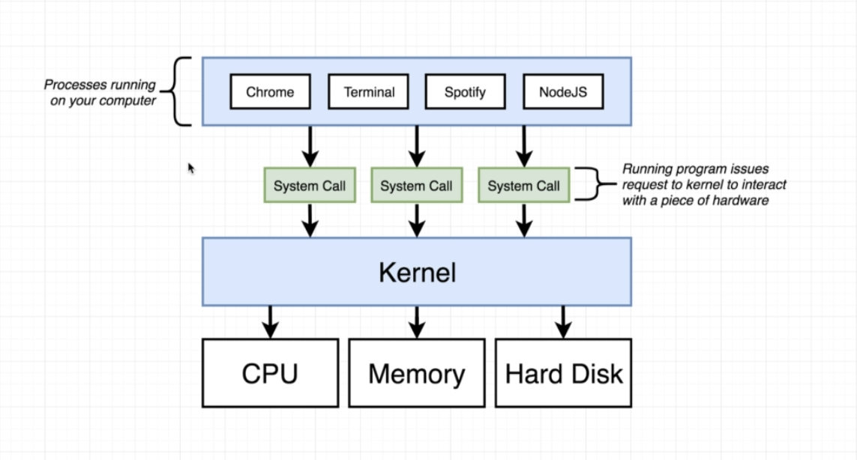

- At the base level, we have the basic OS hardware - CPU, Memory and Harddisk.

- Programs running on our computer, like MS word, Pycharm, etc never interact directly with the hardware.

- There is an intermediate layer between the processes running and the hardware known as Kernel .

- **Kernel is a running process that controls the interaction between the programs running on the computer with the underlying hardware.**

* + Kernel exposes different endpoints for different operations like, writing a file to the hard drive.

Now consider the following hypothetical situation.

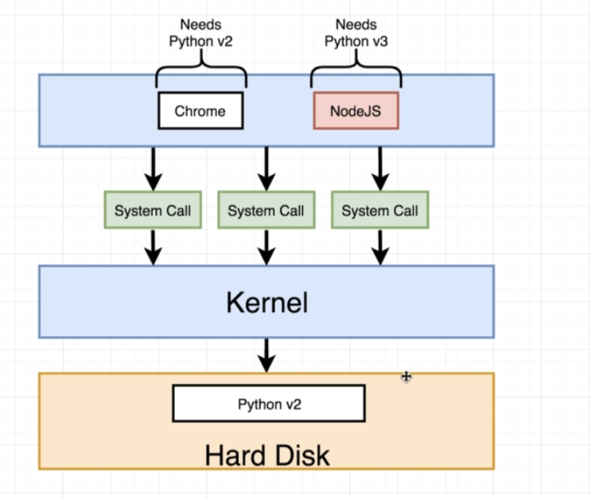

* + Chrome needs Python v2
  + Node JS needs Python v3.
  + For some reasons, we can only install Python v2.
  + So chrome will work fine as we have Python V2 and Node JS won't
  + This situation can be solved in following ways:

* + **Namespace:**
  + Namespace is an **OS feature for segmenting/isolating a hardware resource** for a process or group of processes.
  + Using this feature we can have a specific segment in the hard drive for Python V2 and one for V3.

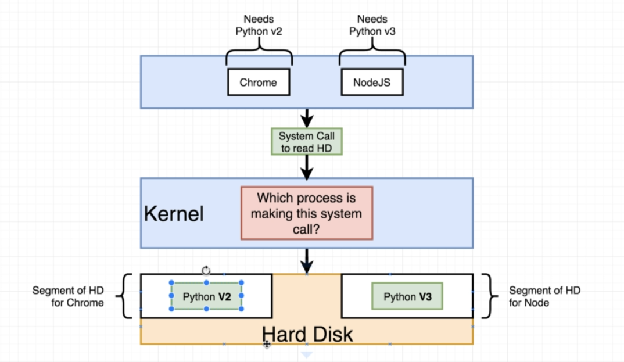

* + So now the Kernel will look into the system call to see whether the request is from Chrome or Nodejs and based on the that it will send the request to the appropriate segment and both the apps will work.

* + 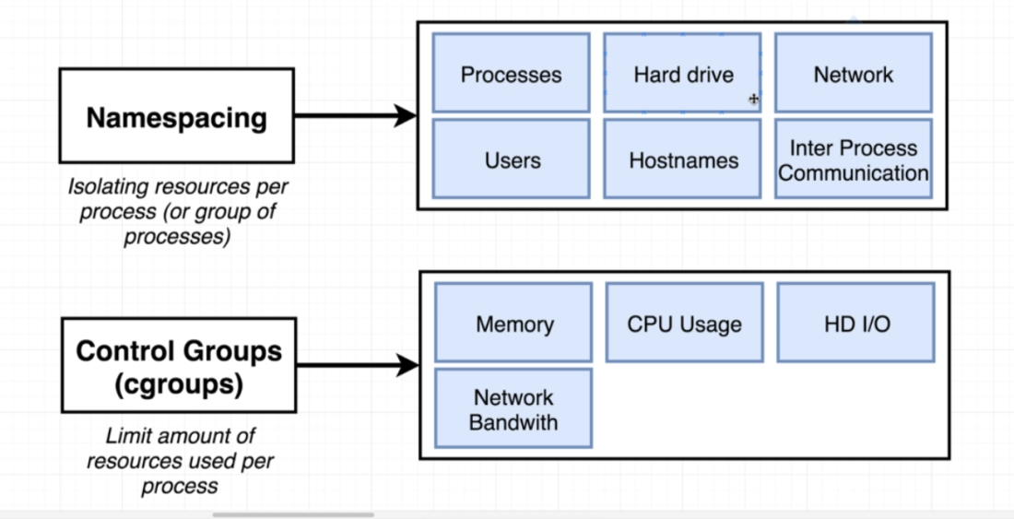

b) Cgroups (Control Groups):

* + Similar to a namespace, we have control groups.
  + Cgroups helps the limit the resources used per process.

In short :: **Namespace can specify the area the hard driver that can be used by a particular process, and cgroup can control the amount of CPU, Memory, I/O and Network bandwidth that the process can use.**

So these two features together can help to isolate a given process.

**So this isolated process is known as a container. See below**

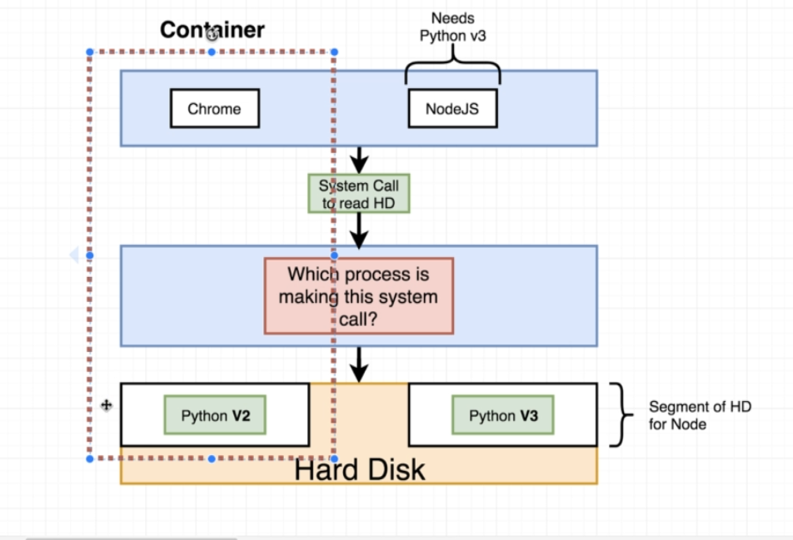

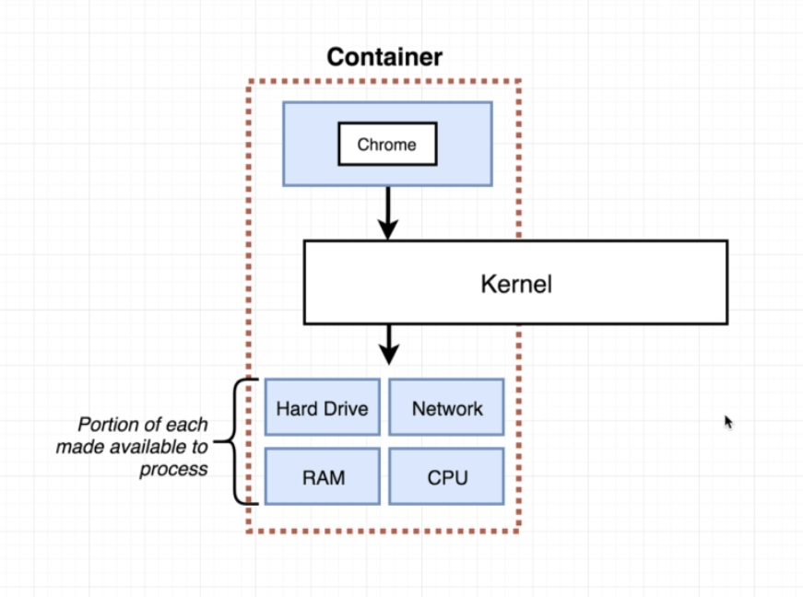

* + **So inside a container, the process will call the kernel and the kernel will decide which isolated segment of memory it can use.**

Containers from an Image:

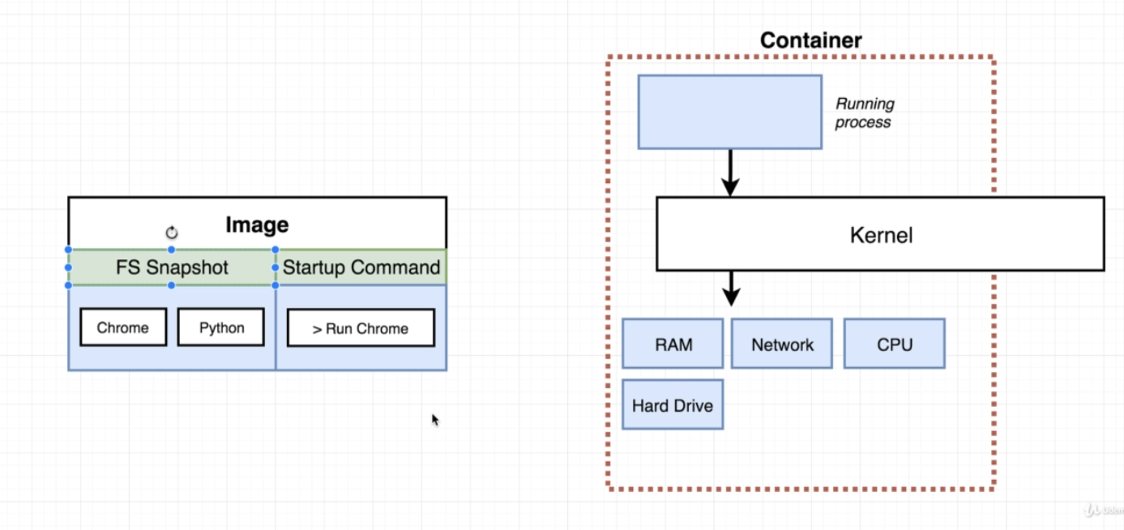

* + An image a copy of a file system snapshot.
  + It’s a copy paste of very specific set of directories or files.
  + Image also has a specific startup command (that we can override)
  + **So we take this image and convert it into a container.**
  + **The kernel will isolate a little section of the hard drive and make it available only for this container.**
  + **And the file format inside the image is taken and placed into that segment of the hard drive**

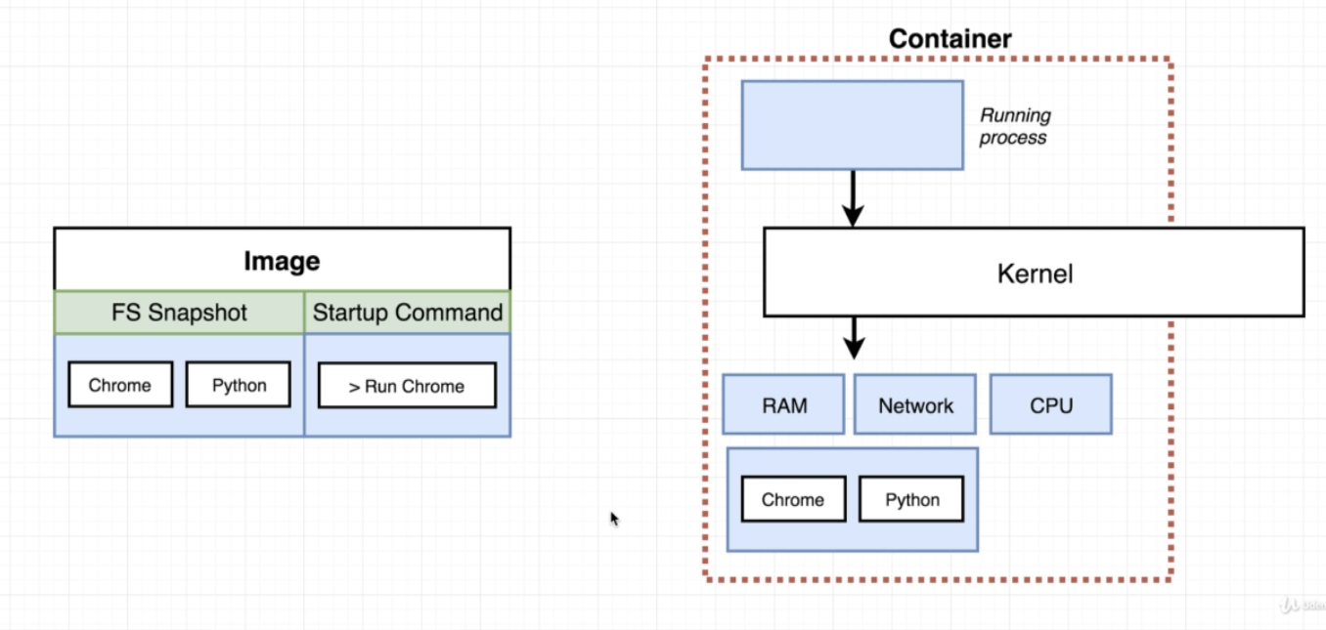

* + And then the startup command is executed.
  + It will start the program inside the container as a running process.

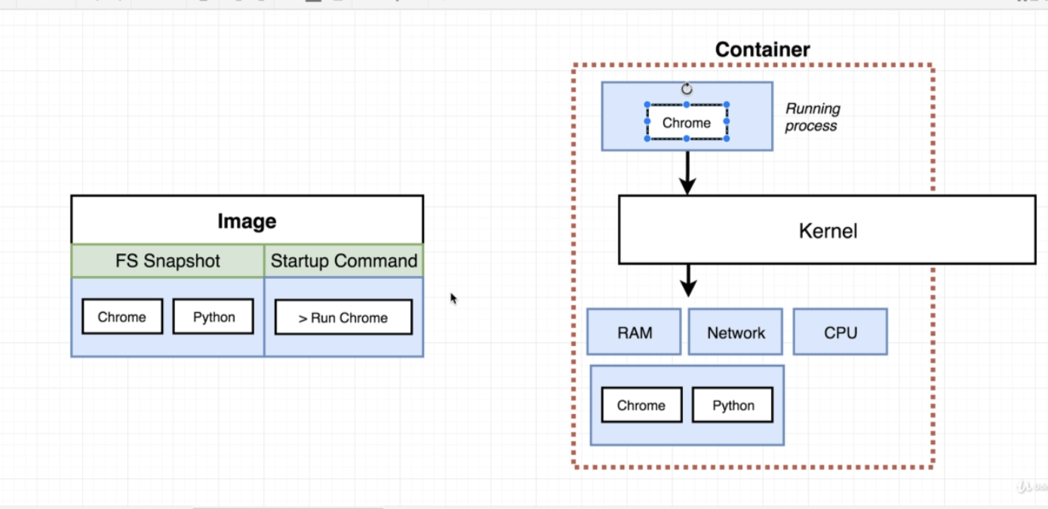

* + Namespace and cgroups are specific to Unix OS.
  + For Windows and MacOS, a l**inux virtual machine i**s also installed when we install docker.
  + All the containers will be created in this virtual machine.
  + This linux VM has a linux kernel for hosting running process inside the container.

--------------------------------------------------------------------------------------------------------------------------------

Commands:

* + Docker Run
  + To start a container from an Image

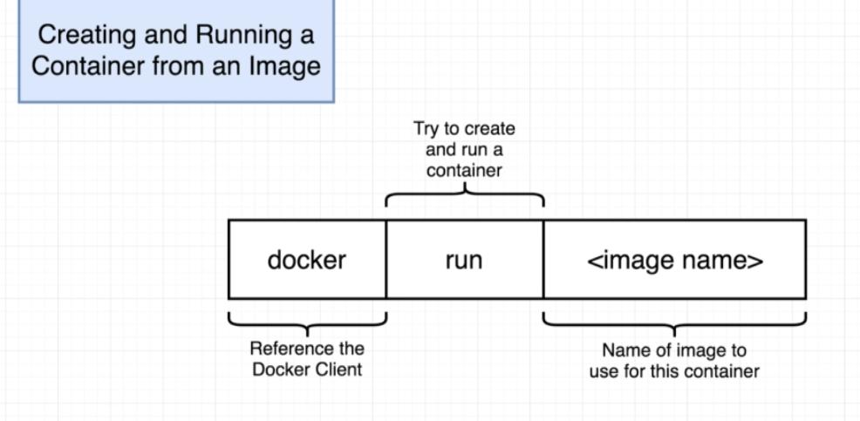

* + **So every image comes with the File system snapshot and a default command that is compatible with that file system structure.**
  + We can override the default command by passing in our own commands with the run command.

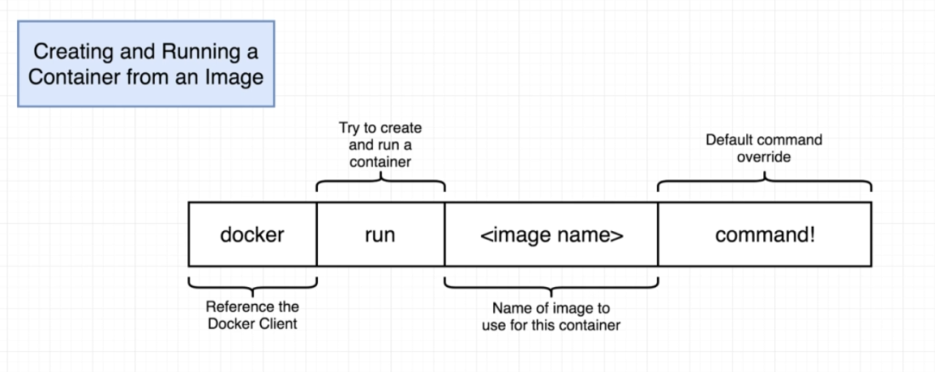

- If the over ridden command that we pass in is not compatible with the file system snapshot structure, then we will get an error. For example:

- docker container run hello-world ls : will give us an error as ls is not compatible with the FS snapshot of the hello-world image.

* + To List the available containers in the machine:
  + Docker container ps : to see only the running containers.
  + Docker container ps -a : to see all the available containers.

* + Container Life cycle:

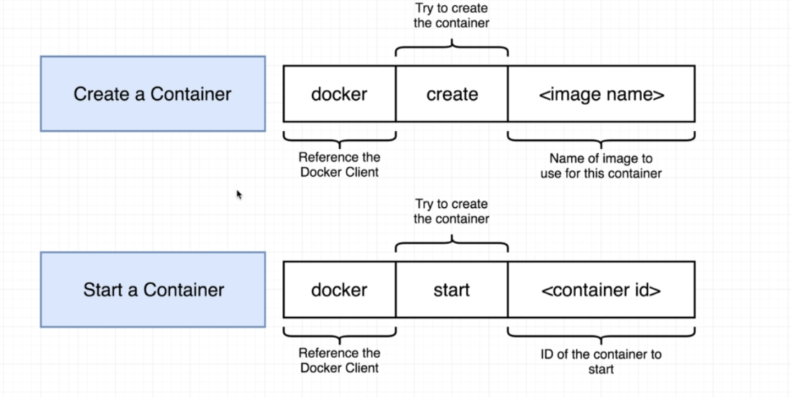

* + Create -> run -> start -> stop -> (start again) ->
  + Docker run = docker create + docker start
  + **Docker create takes the File system snapshot and places it inside the hard drive segment for that process.**
  + **Docker start will start the actual process and thus the container.**
  + Docker start by default does not show logs (unlike docker run) so we need to use -a in docker start to show the output/logs.

* + Starting stopped container:
  + Docker container start <id of the container>
  + **Docker start will start the container with the default command that was used when container was created. We can't override this default command.**

* + Removing stopped containers:
  + Docker system prune :

- removes all the containers.

- Also removes the images from cache

* + Retrieving log output:
  + Docker logs <container id>
  + Docker logs does not run or start a container. Its just for seeing the logs.

* + Stopping container:
  + 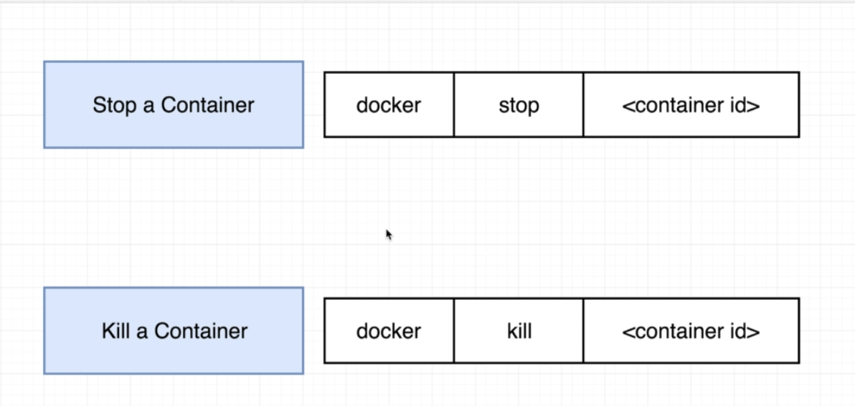

Docker Stop:

* + Sends a hardware signal to the process running inside the container.
  + SIGTERM - Signal Terminate is sent to the process in case of Stop command. It tells the process to shut down at its own time and do some clean up before shutting down.

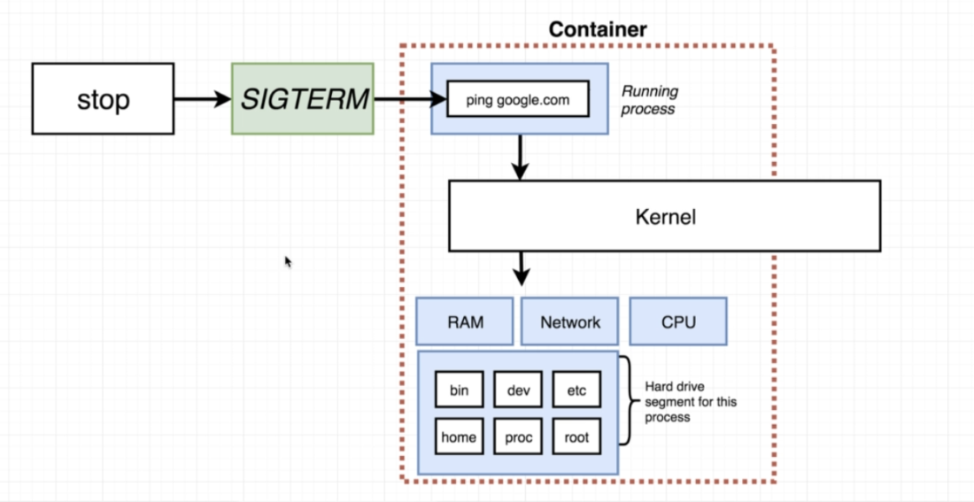

* + Docker stop command stops the container but also gives it sometime to do some clean up.

Docker Kill:

* + Docker kill stops the container immediately.
  + SIGKILL: Signal Kill is sent to the process running inside the container. It means to shut down immediately.

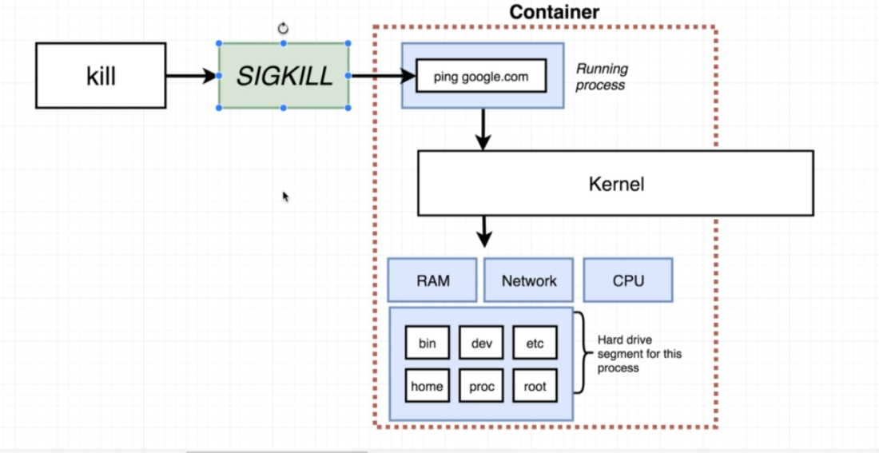

* + If docker stop is not able to stop the container, then it will eventually use the docker kill command after 10 seconds.

* + Getting inside a container:
  + 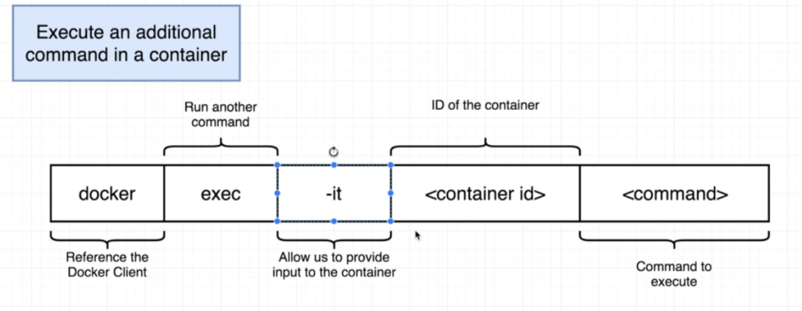

- For this we can use 'exec' command: This means to run an additional command inside a container.

-it flag:

* + Every single docker container is running inside a linux virtual machine (even if you are on mac or windows)
  + Every process in a container has 3 communication channels attached to it - STDIN, STDOUT, STDERR
  + These channels helps the communicate info into the channel and outside the channel.
  + STDIN: communicate info into the process.
  + STDOUT: gets info from the containers shows it onto our terminal .
  + STDERR: get error info from containers and shows it in our terminal.

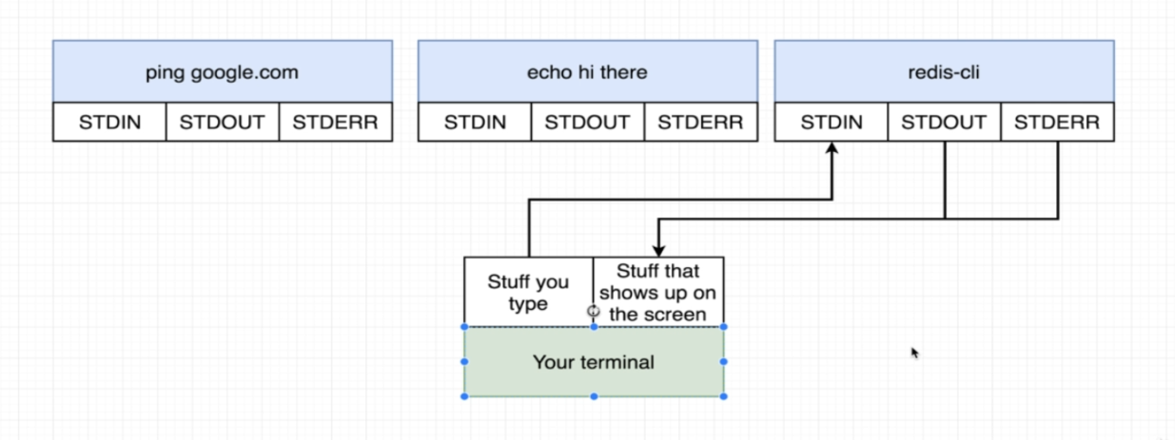

- '-it' a combination of '-i' and '-t' flag.

- 'i' flag means to attach the terminal to the STDIN channel of the container. So any stuff typed in the terminal gets directed to STDIN channel of the container.

- '-t' flag helps to make all of the interaction with the container via the terminal a bit pretty. See below there is no proper format if we don't use -t flag.

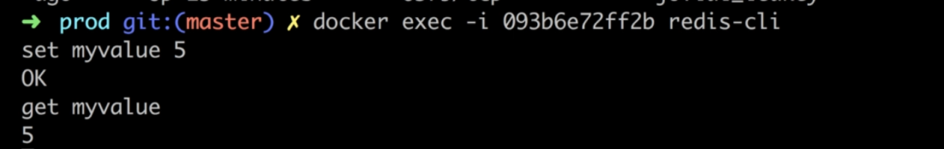

* + Opening terminal in a Container:
  + For this we need to understand what command processer is being used inside the container.

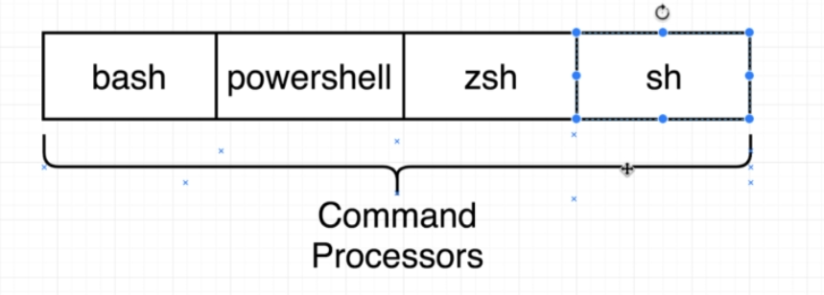

- After knowing the type of command processor we use that as an override command.

docker exec -it <container id> sh/bash

* + Common use case is to first start the container with the default command. And they do a 'exec' to get inside this running container
  + We can also use -it with the docker run command but that will override the default docker command and container will be exited as long as we close the terminal.

Docker attach:

* + Its used to attach the terminal to the STDIN, STDER and STDOUT communication channel of the primary process (process with process ID 1) running inside the container

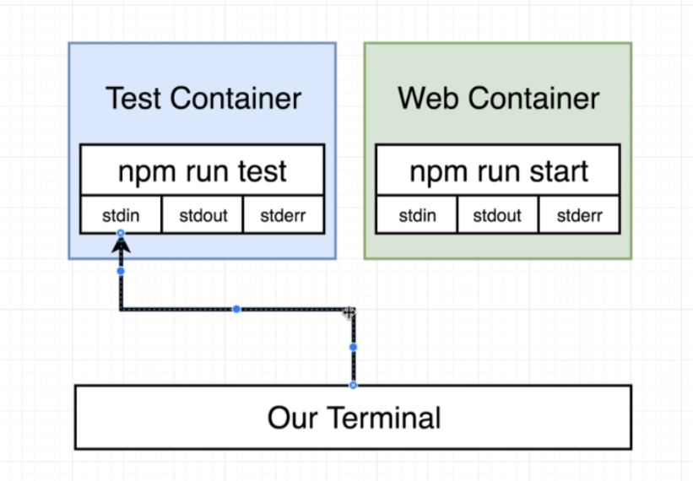

* + Container Isolation:
  + Each container runs in isolation.
  + Two containers for same image does not share any resources between each other. Changes to one container won't reflect in the other one.

----------------------------------------------------------------------------------------------------

* + Images:

* 1. Creating Images:
  2. 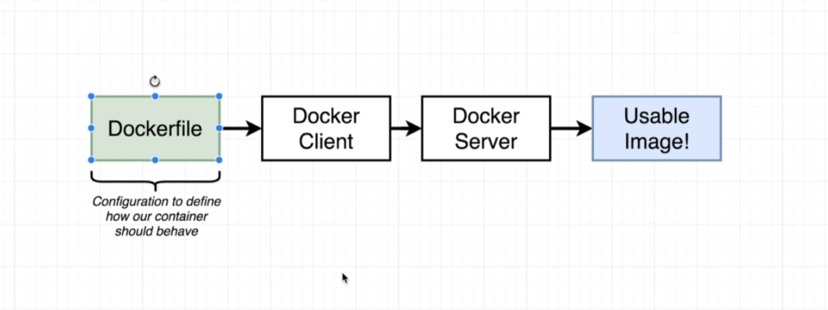
  3. We create a dockerfile that has some configuration defined in text file.
  4. We invoke this dockerfile using docker client.
  5. Docker client gives this file to docker server.
  6. Docker server does all the heavy lifting like pulling the image from the docker hub etc.

* 1. Basic flow to create a docker file:

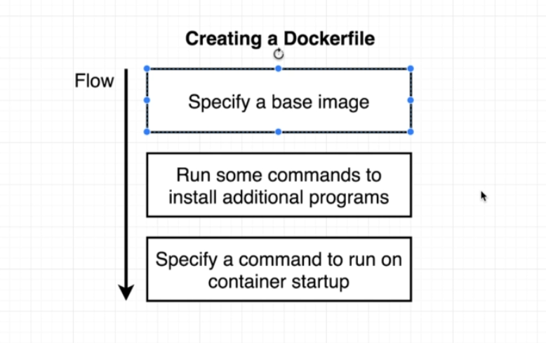

c) Creating Docker file:

* + Docker file name should be named 'Dockerfile'
  + Comments can be added using #
  + Sample docker file for redis image.
  + 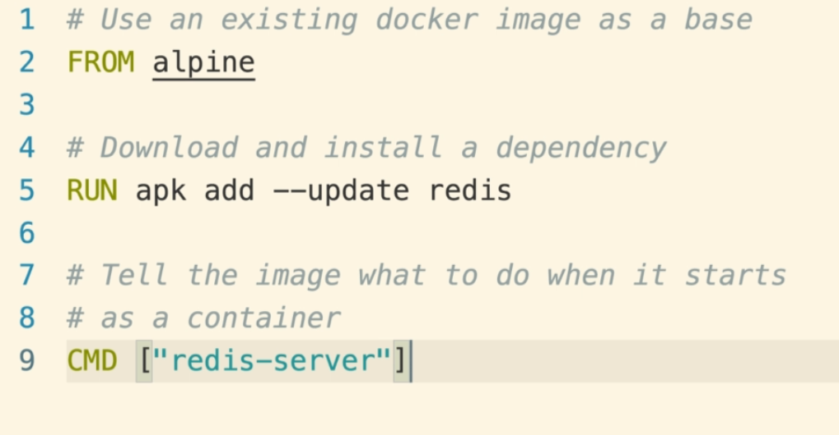

* + Dockerfile configuration:
  + Every dockerfile consists of an instruction and some follow up arguments for that instruction.

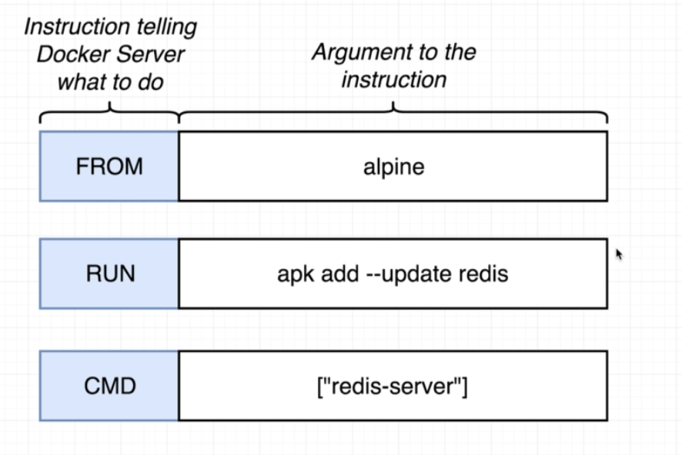

* + Docker base image:
  + The analogy:

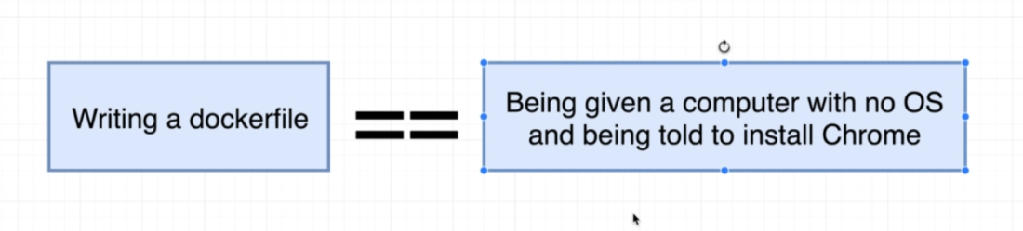

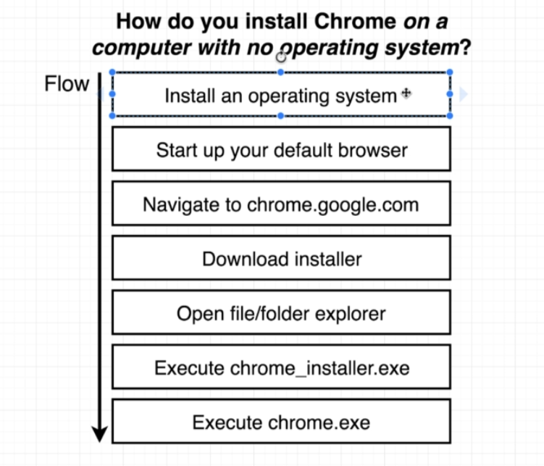

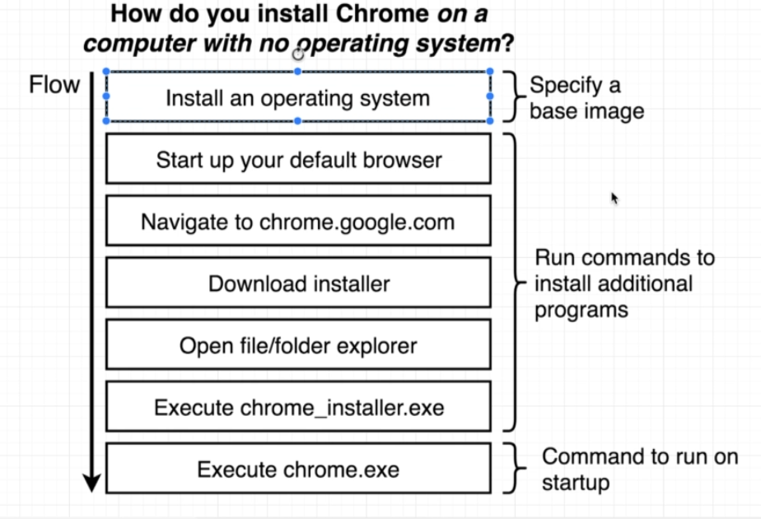

* + So the base image is the initial requirement/or OS that we need to build our container.
  + We normally use some lightweight OS distro like alpine that will give **us some preinstalled set of programs ( apk package manager in this case)**

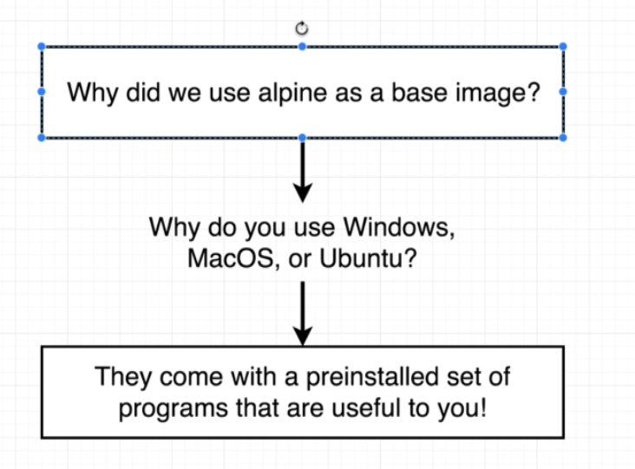

* + Docker build process:
  + Checkout lecture 029 for detail. It has good details.
  + We use 'docker build . ' command to create an image.
  + Docker build -f <filename> . : when the file name other than Dockerfile
  + The . Is the build context ?
  + Docker build -t <tagname> .
  + -t flag is for tagging the image so container can be created based on that tag name.
  + Tag format:

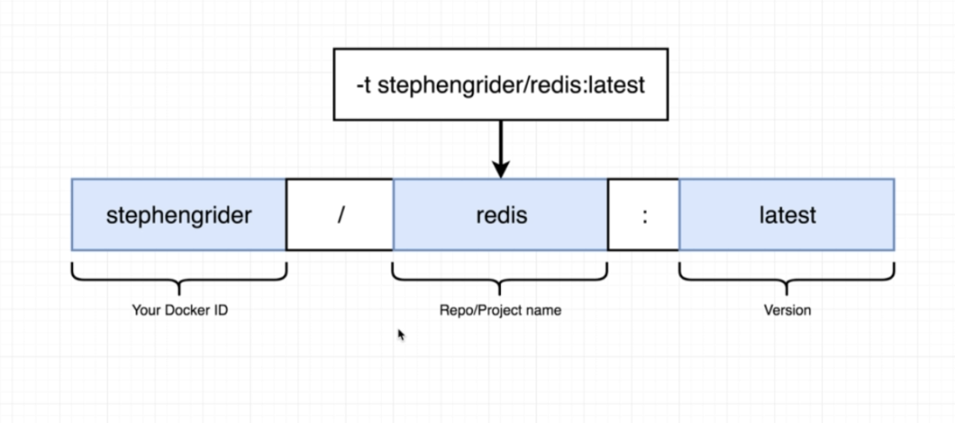

* + 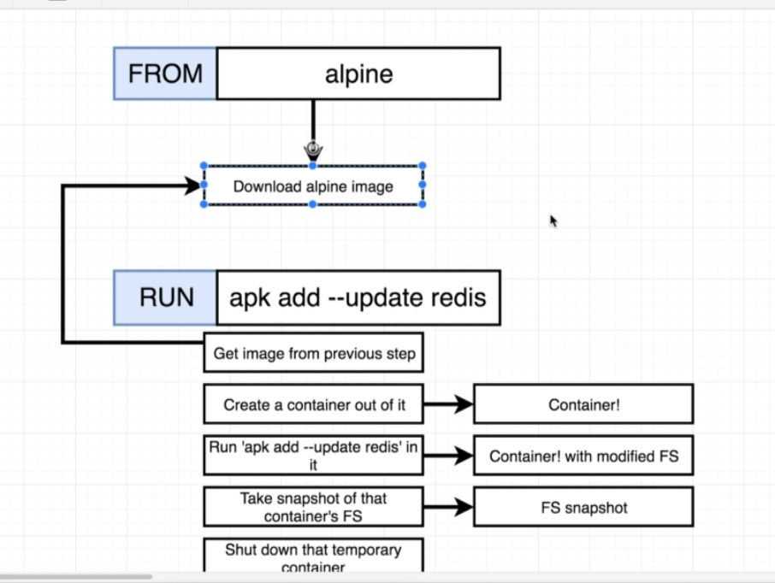

* + 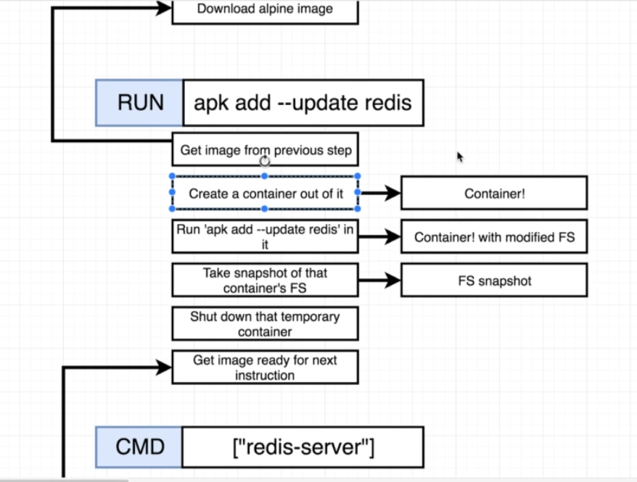

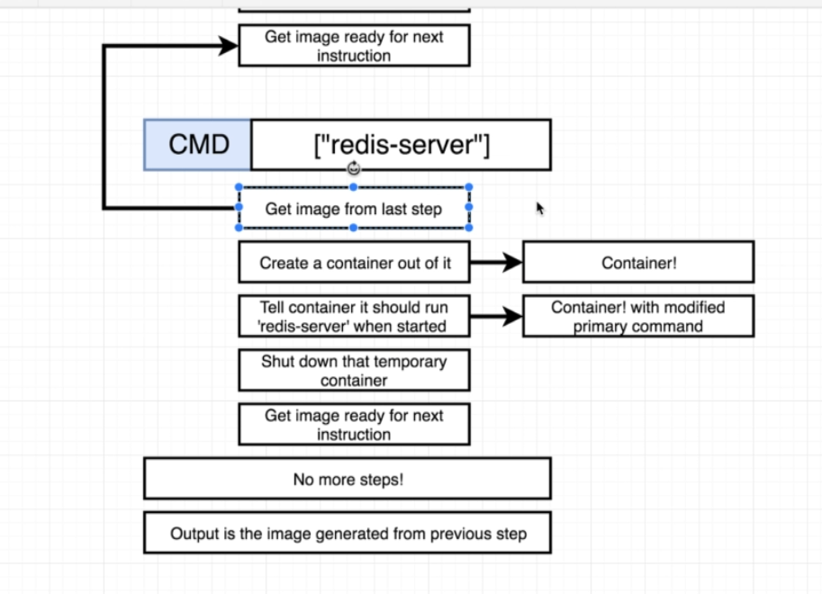

* + For every instruction in the dockerfile (other than the first one), the image from the previous step is used.
  + That is, image fs snapshot from previous instruction is placed in the memory and container is created on top of it.
  + After that, the process is executed on the container to complete the execution of that step.
  + After execution of the step, that container is deleted.
  + Now the updated file system snapshot is used a temporary image for the next step.

* + Image Tagging:
  + Helps to give names to the image so that we don't have the use the ID.
  + Docker image build -t <tagename> .



* + Creating image out of a container:
  + We can use the commit command to do that:
  + To do this use 'commit' command with the default start up command for that image.
  + Docker commit -c 'CMD ["redis-server"]' <containerid>

* + Copying build files:
  + In order to execute some build files for our project, we need to copy them into the working directory inside the container.
  + We use 'copy' command for this.
  + 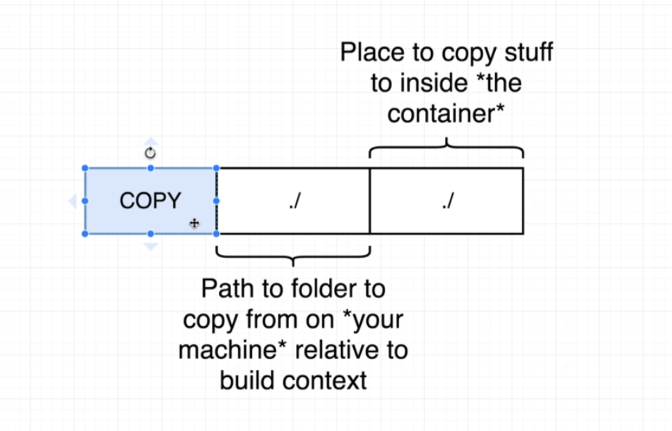

* + ./ means the current working directory.
  + COPY ./ ./

* + **Container port Mapping:**
  + A container is it owns isolated set of ports.
  + But by default, no traffic from the host machine is routed towards these port.
  + So, by default, no incoming traffic to our computer can redirected to the container.
  + We need an explicit port mapping to achieve this.
  + Port mapping means any incoming request to the computer should be routed to container at a given port.

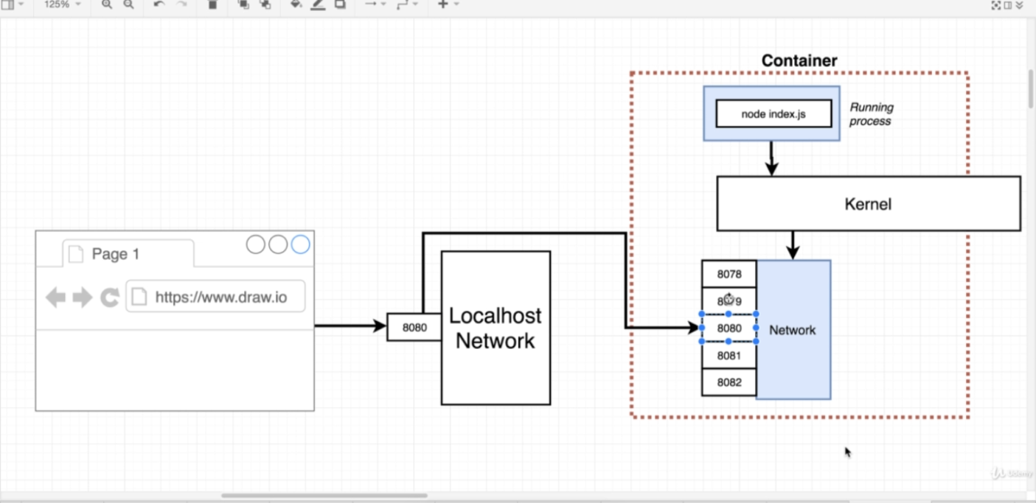

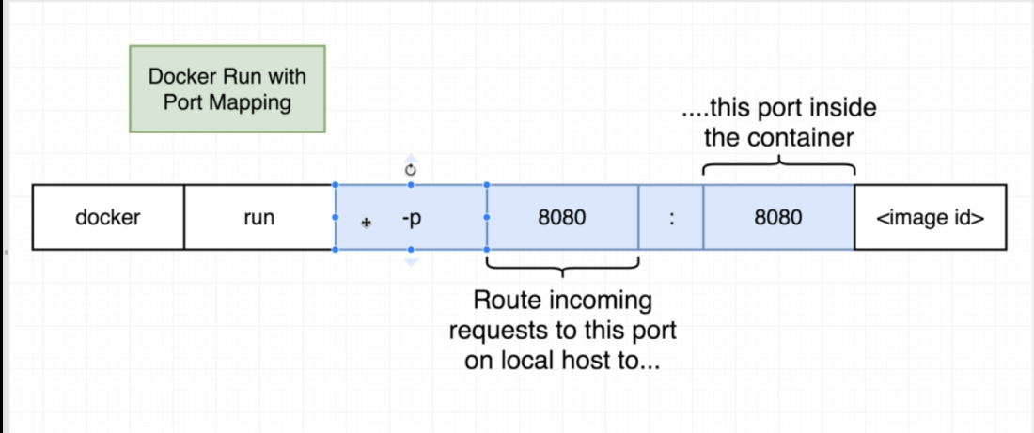

* + Host machine port and container port need not to be identical.

* + Specifying a working directory:
  + Instead of copying everything in the root directory of the container, we can specify a working directory
  + 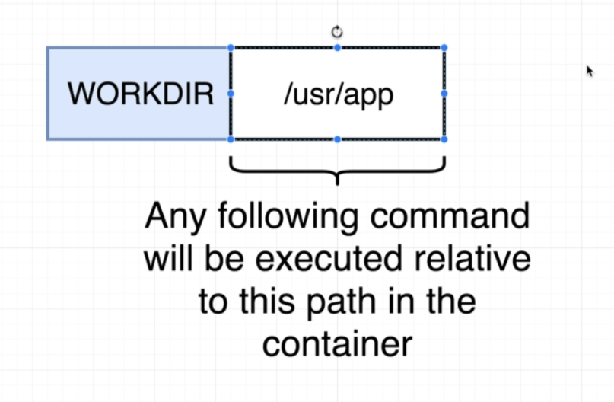
  + WORDIR helps us to specify a director that will be used for subsequent COPY commands.
  + The directory name passed as an argument to this instruction will be created automatically if its not there.
  + Specifying WORDIR also affects the exec command into our running container. When do a shell into our running container, it will start from the workdir only.

* + Unnecessary Rebuilds:
  + When we make some changes to our Project files, then those changes won't be reflected in our new container, as our container is using the old image.
  + We have to build the image again.
  + And once we change our project and rebuild the image, the docker notices the change in the project file while copying and due to it will rebuild the steps below it again.
  + To avoid this unnecessary build, we can only copy the dependency file first, then install dependencies and after that copy the other files.
  + This will avoid rebuilding and installing dependencies if any of the project file was updated. (See lect 44 )
  + 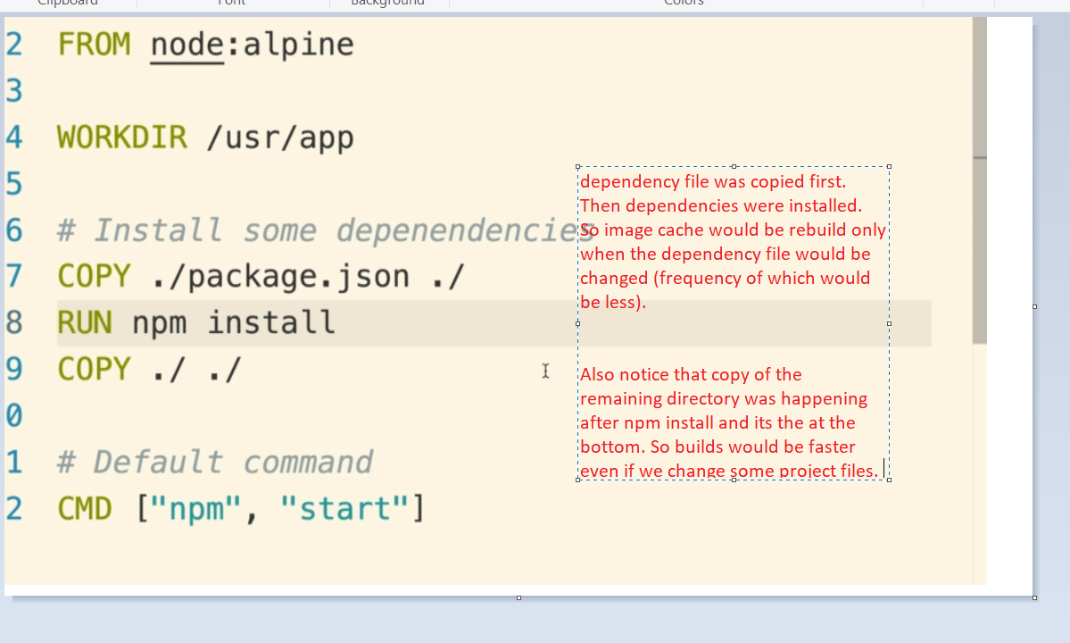

--------------------------------------------------------------------------------------------------------------------------------------------------

* + Docker Compose:
  + Two app running on different containers have no communication between each other.
  + So we need to setup some network infrastructure between the two.
  + For working with multiple containers we can use docker-compose

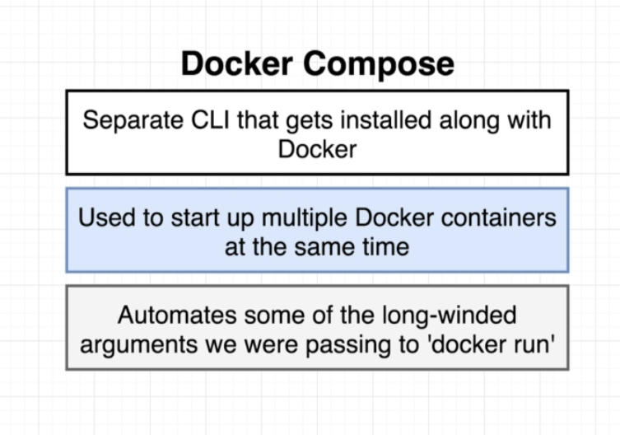

* + It functions like docker cli but helps avoid writing long arguments.
  + So we create a docker-compose.yaml file and put our multiple docker commands over there.

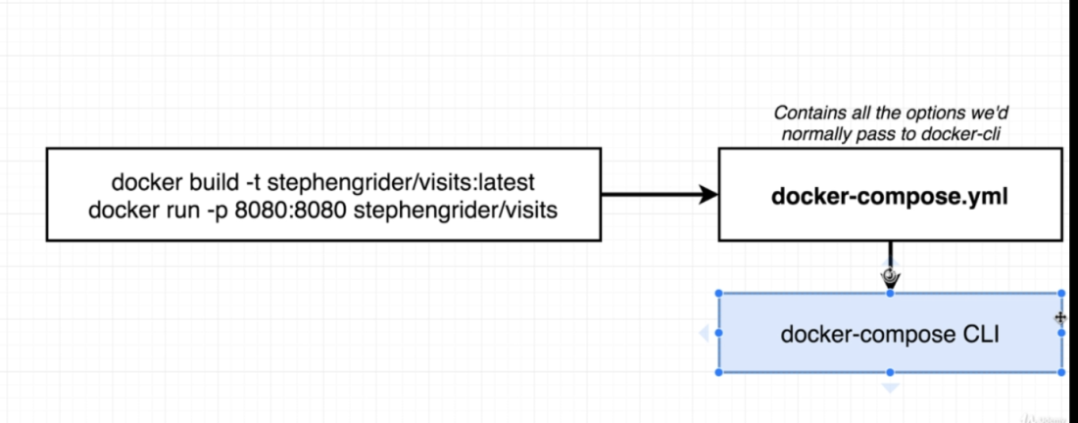

* + Sample docker file

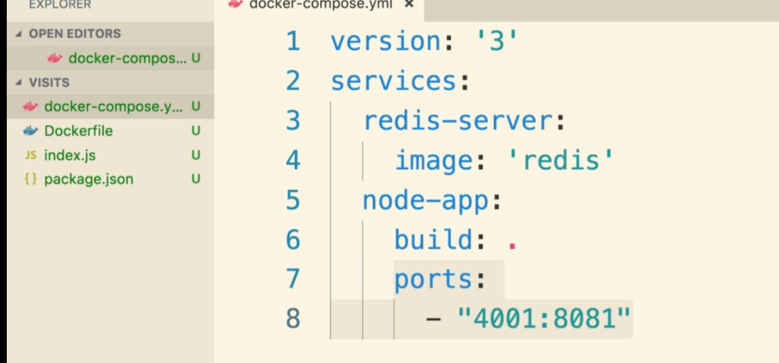

* + The build parameter takes '.', it searches for 'Dockerfile' in the current context (folder).
  + So incase we have named our dockerfile differently or its not in the current context, we can use following:

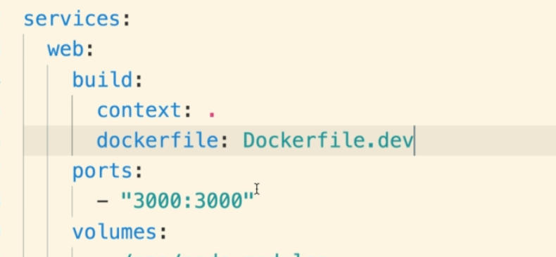

Context: is the directory or context.

Dockerfile: is the docker file name.

* + Networking with Docker:
  + Just by creating a docker compose file and adding containers inside the services, the docker-compose will establish the connectivity between the two.
  + 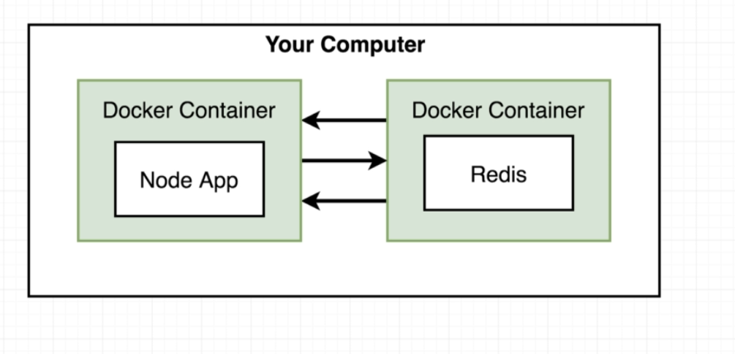

* + 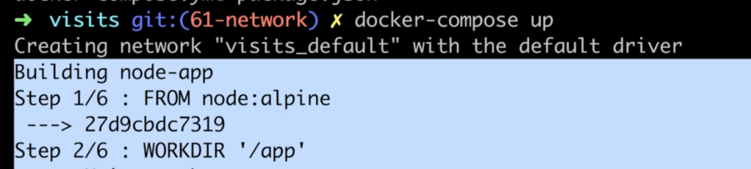

* + Docker compose commands:
  + One of the purposes of docker-compose it to be avoid writing the long docker run commands in the console again and again.

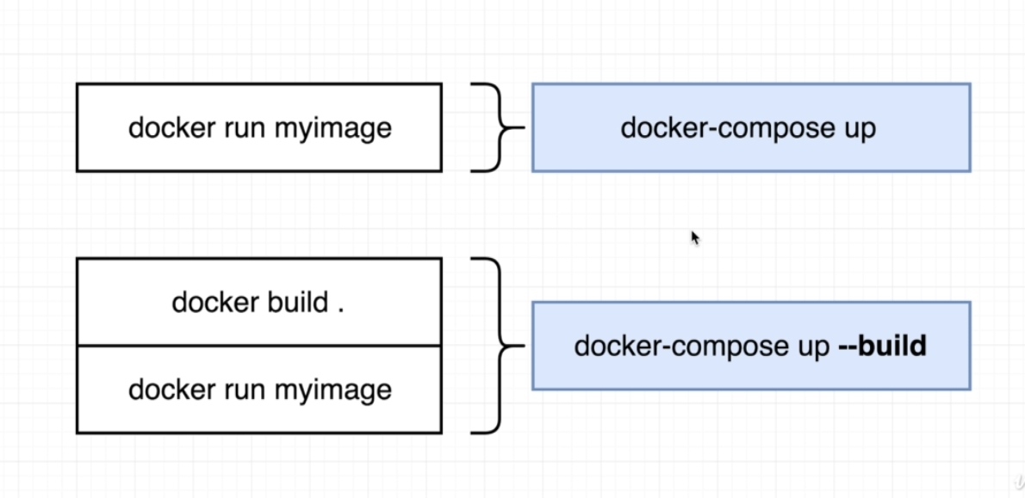

* + Docker-compose up: to run the docker-compose.yml file in the current directory.
  + Docker-compose up --build: To rebuild the images inside the docker file.
  + Docker-compose up -d : to start and run the containers in the background.
  + Docker-compose down : to stop the containers.
  + Docker-compose ps : to see the docker container status.

**Note: While using docker-compose its important to be on the same directory where 'docker-compose.yaml' file is present.**

* + Container maintenance/ Automatic Container restarts:
  + We can apply restart policy to our containers when it fails.
  + By default there is a 'no' restart policy applied to all of our containers.
  + Below the common restart policies that we can use:
  + 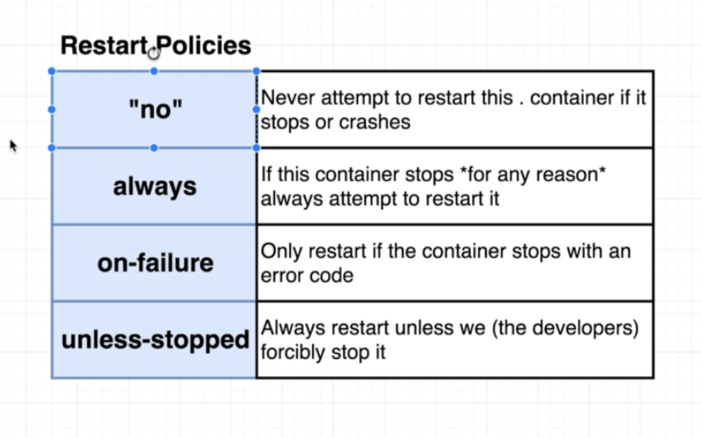
  + How to add it:
  + 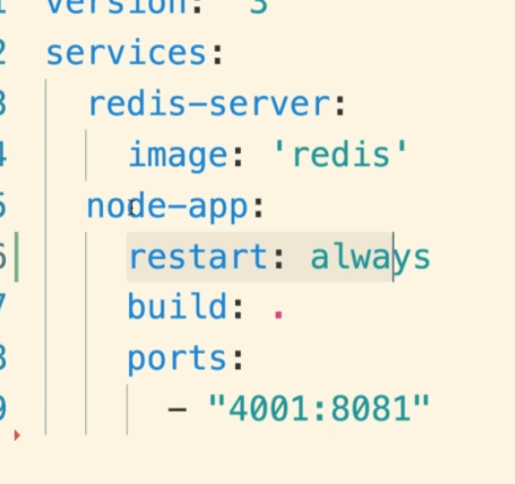

* + If we are using 'no' restart policy then we have to add it as string (because 'no' is keyword in yaml which means false).

* + Docker volume:
  1. With volume, we create a mapping between a file/folder inside the container, with a file/folder inside the project.
  2. 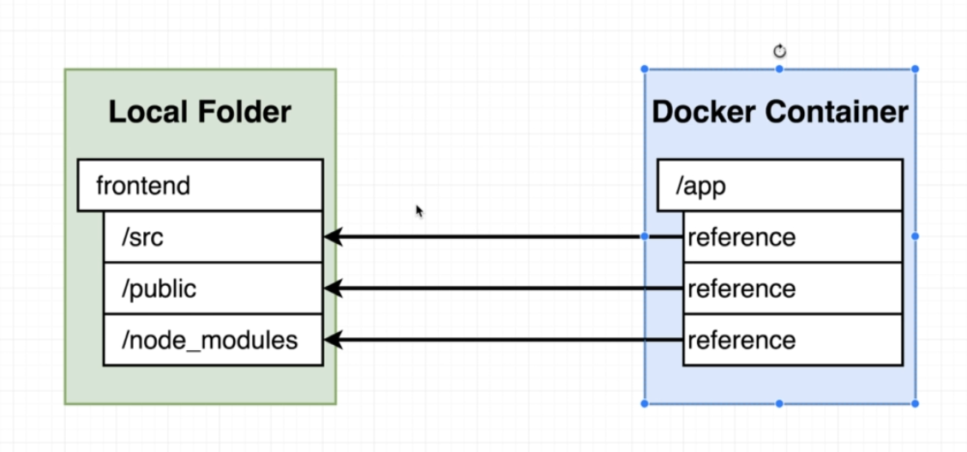
  3. We can use '-v' flag with in the docker run to provide the volume..
  4. Docker container run -v <projectFolder>: <containerFolder> ….
  5. This means that any time container is trying refer some folder inside the 'app' directory, it should refer the folder its mapped to outside the container

* 1. Instead of writing these long -v flags in docker run command, we can use them in docker-compose file using 'volumes' property:

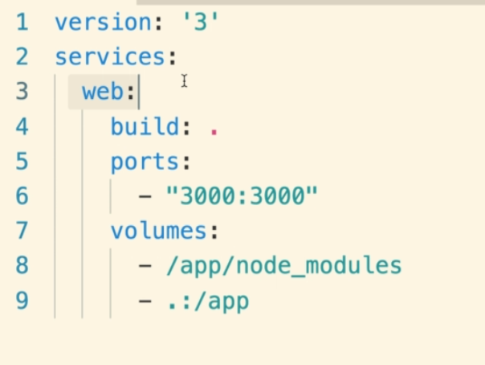

* 1. Production grade workflows with Docker.
  2. The flow:

